The Corporation of the Village of Slocan
PO Box 50, 503 Slocan Street, Slocan BC, V0G 2C0
P: 250-355-2277 | F: 250-355-2666
mayor@villageofslocan.ca

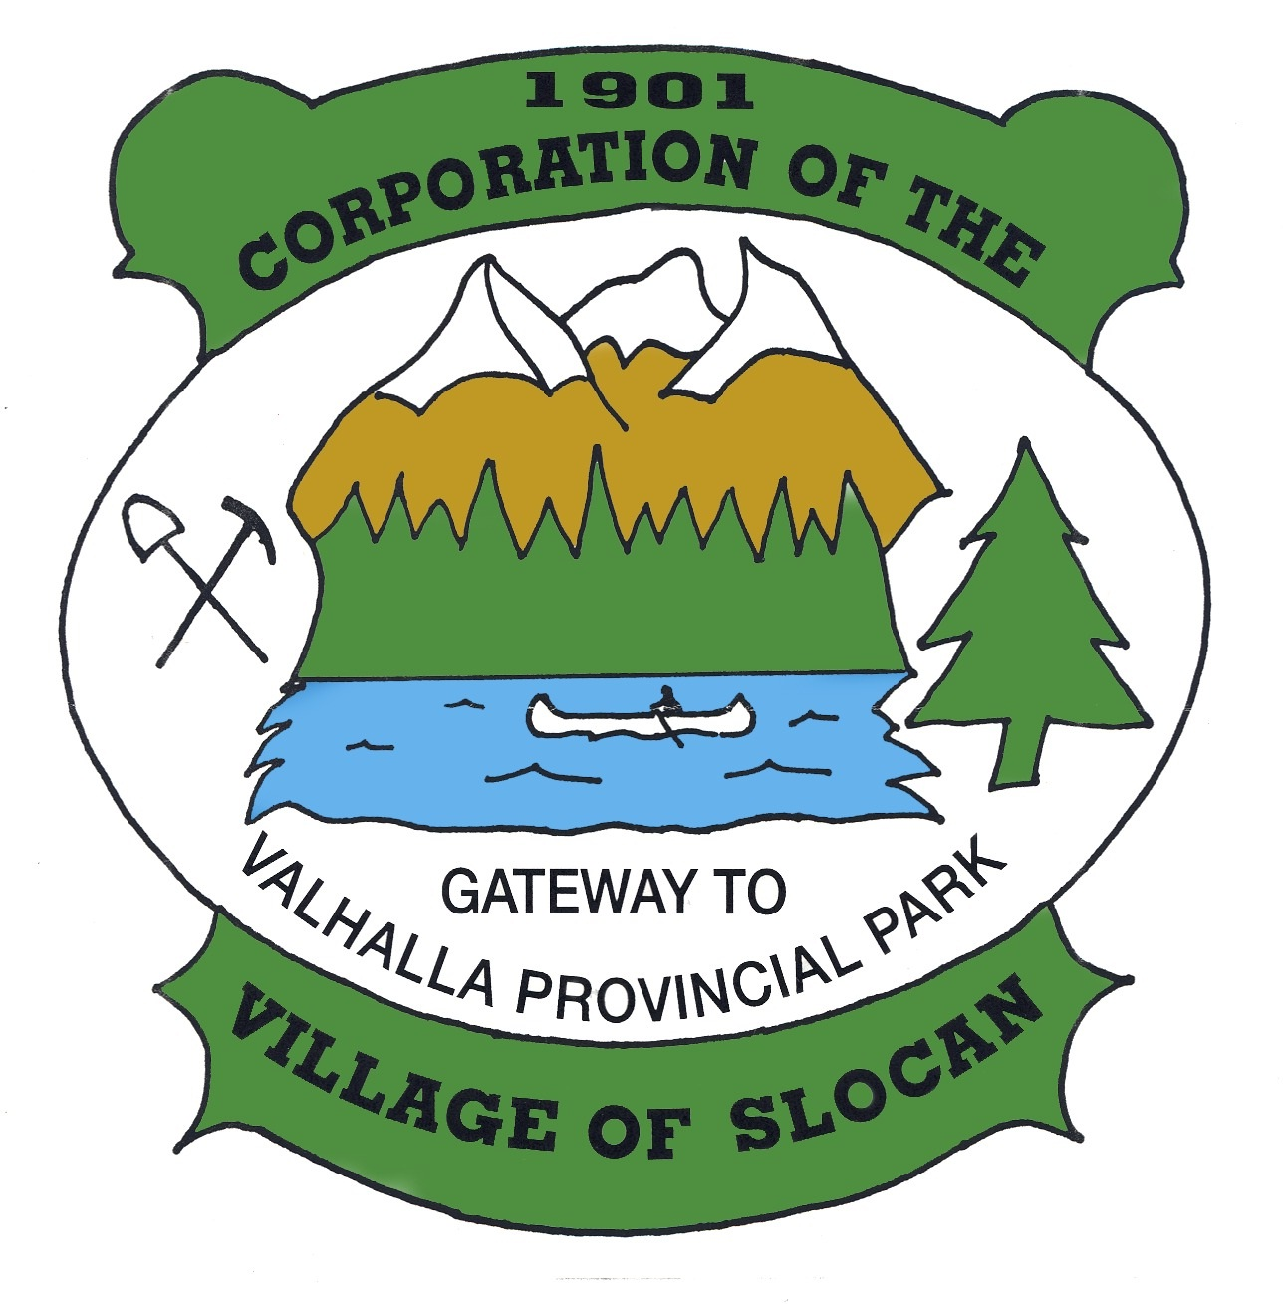

Springer Creek Micro Hydro Project
- Frequently Asked Questions –
What is the micro-hydro project?
Micro-hydro is a form of renewable energy production using hydropower generation. It produces electricity from the natural flow of water, producing power through the flow and pressure developed by a drop in elevation.
Why is Slocan exploring micro-hydro?
The Village has been investigating the possibility of developing a hydropower project on Springer Creek since 2003. The project has been a priority with every Council since that time. It has been identified as a project that will contribute to our economic sustainability and will build our capacity to invest in our community for generations to come. Ultimately, it will provide us with a localized source of renewable energy – a community owned, renewable energy asset.
How much energy will the project generate?
The project is anticipated to generate a maximum of 800 kilowatts and produce approximately 3000 megawatt hours. This is approximately the amount of energy that 225 households would consume in a year.
Will the energy generated be sold back to Slocan residents?
Are we going to become our own utility?
The power will be sold to BC Hydro for use in the larger grid. This provides maximum social and economic benefits to the community. In the long-term, however, we do need to consider what we will do with the power when a contract with BC Hydro expires. At that point we may want to utilize the power for a specific civic energy needs. The Village will retain all the rights to the development and will review what would be in the best interests of its residents at that time.
How much revenue will the project generate? What will we do with the revenue?
Revenue will be based on our contract with BC Hydro. We still need to secure this contract before the project is a “go.” Based on historical SOP (BC Hydro’s Standing Offer Program) rates, the Village average annual gross revenue is projected to be approximately $294,000, less expenses for any debt servicing and operations. Net annual revenue is estimated to be approximately $170,000 to start.
The revenue will be utilized to provide project assistance, programs and services to the community. As we move closer to project completion, this is a robust conversation that we look forward to having with the community.
What other benefits are there to the community?
Project construction will provide opportunities for employment. Once built, the project provides significant economic benefits that we can reinvest into the community. The project also demonstrates what a small scale, low impact micro-hydro project is. The location affords opportunity for sharing this information with others, potentially as an eco-tourism destination or through other avenues.
In the long term, it is a source of localized renewable energy that belongs to the community and is for the community. Slocan, like every community, needs to do its part to move towards a post carbon economy.
Where will water be diverted? Will there be a dam? Is there enough water?
There is no dam. A portion of the stream flow will be diverted from above the upper canyon and returned to the creek above the campground. There is enough water. As a community energy project, we have control over flow diversion. We are obligated to ensure that flow diversion does not exceed a maximum amount and we are committed to responsible management of our system, considering all of our community values.
What about the fish? Will the project destroy fish habitat? How will health of the fish be monitored?
The Village and the Province are committed to ensure maximum health of fish habitat. As part of the pre-development process, Masse Environmental Consultants (MEC) were hired to conduct fish and aquatic assessments.
A number of barriers to upstream fish passage were observed during the course of the habitat assessment. Within the diversion reach, seven waterfalls ranging in height from 2 – 20 m were observed. In addition, the 35 m culvert under Highway 6, and several bedrock chutes, are also considered barriers. These barriers subdivide the diversion reach into 9 sections ranging in length from 15 – 230 m with respect to fish movement. Downstream of the proposed powerhouse, two waterfalls, an old weir, a culvert, and the flume under the mill are present and prevent upstream migration from Slocan Lake into the diversion reach.
Fish sampling confirms that rainbow trout are present within the creek. However, the lower falls and the upper canyon falls provide natural barriers to fish.
To ensure the continued integrity of the fish population on the creek, the Village has committed to an Adaptive Management Plan as an integral part of the project. This will require the fish population to be monitored on an intermittent basis, with the results compared to the pre-project conditions. If a negative effect is observed, adjustments to the project operation and/or alternate mechanisms for mitigation would be employed to reverse these effects.
Why Springer Creek? I’ve heard that it would be better on a different creek?
Given the proximity of the creek to the Village, it affords significant opportunities for the development of the project that many other sites cannot provide. The powerhouse will be on Village land, allowing reduced costs from land tenure and ease of operation. The proximity will also mean lower construction costs and footprint in relation to the more remote locations that many hydropower developments encounter.
The configuration and location of Springer Creek provide good opportunity for the development of a cost efficient micro hydro project. The creek experiences a significant drop over a short distance, providing optimal conditions for power generation. Also, the location of a grid connection in close proximity to the project will also provide cost savings.
What about solar energy? Why isn’t this a solar or wind project?
Researching viability of projects take time and resources. The development of this project does not preclude our ability to look into solar and other renewable energy initiatives in the future; the project will actually increase our capacity to do so. With that being said, this project does make sense for where we live, utilizing our natural assets in the most efficient way possible.
For reference, a comparable solar energy project is the Kimberly Sun Mine. The footprint of that project is noteworthy. It made sense for their location, as it was developed on a contaminated site. Find out more at www.sunmine.ca
I have skills and would like to work on the project. How do I get involved?
The Village is at the very early stages of progressing the project to the design and construction phases and the exact opportunities for community participation have not been finalized. However, as this is a community project, the Village will be looking out for every opportunity to maximize community participation. We will be hosting upcoming information sessions, stay tuned!

