. 

THE CORPORATION OF THE VILLAGE OF SLOCAN
Box 50, 503 Slocan Street
Slocan, B.C. V0G 2C0
Ph: 250-355-2277 Fax: 250-355-2666
info@villageofslocan.ca
MARCH 2017
OFFICE HOURS:
Monday to Thursday from
9:00am to 4:00pm
(Closed from 12 noon to
1:00pm for lunch)
Closed on Fridays.
2017 Council Meeting Schedule
January 9 May 8 September 11
February 14 (Tues) June 12 October 12 (Tues)
March 13 July 10 November 13
April 10 August 14 December 11
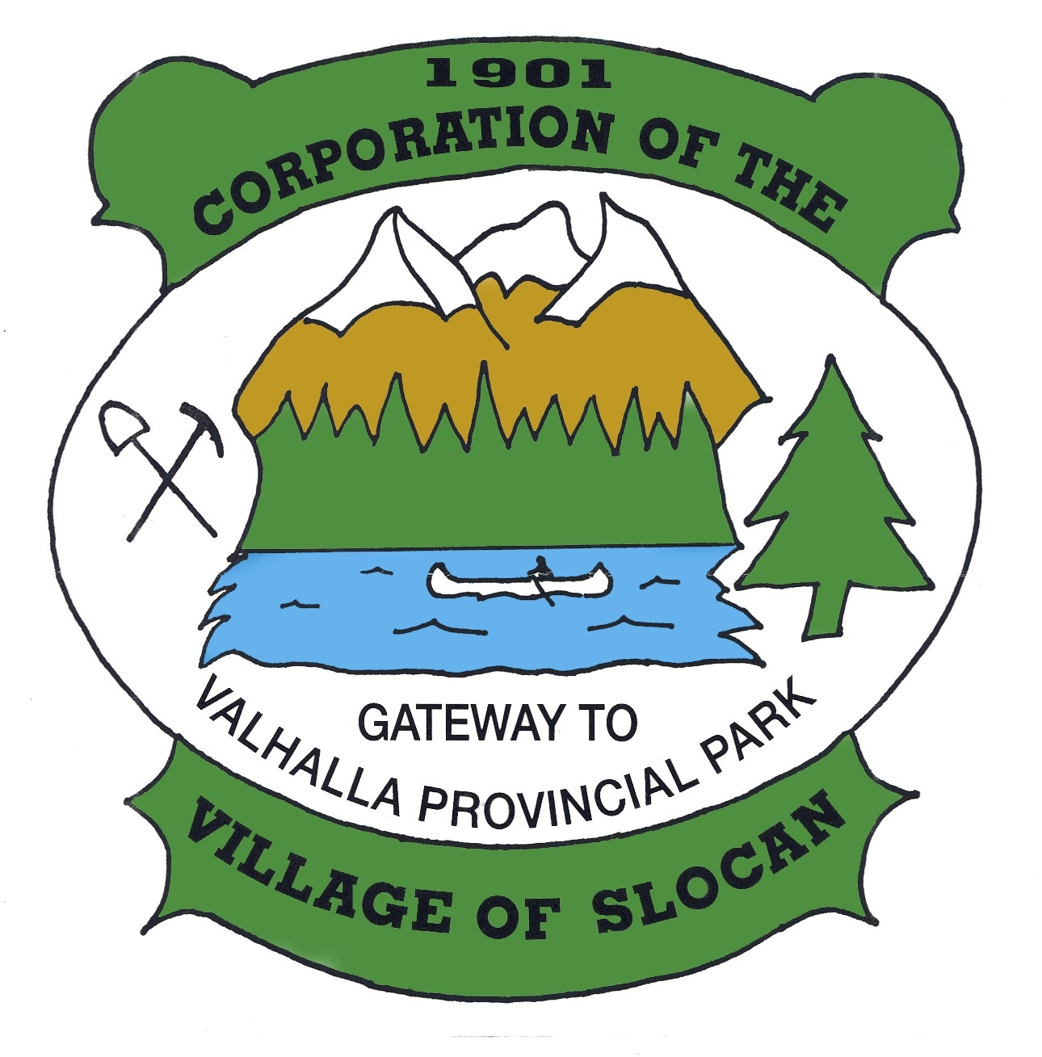

2017 UTILITY BILLING

Please be advised that the 2017 Utility Bills were due March 1st. All Accounts with a balance after March 31st will receive a 10% penalty. Unpaid balances on Dec. 31st will transfer to taxes.

Payments can be made at any time of year towards your taxes or utilities and will be applied to your account as a credit/prepayment.
You can come into the Village Office and make payments with a debit card or cheque or if you bank with a credit union/BMO, payments can be made online!

ATTENTION FITNESS CENTER USERS
The Fitness Centre WILL BE CLOSED
From 8:00am to 12:30 pm on Saturday March 25th
For an organized fitness workshop. You must be 16 years or older to register and pay a $10.00 fee in order to attend this event. Sign up at the Village Office Monday through Thursday. There will be certified trainer that will cover warm-ups, stretching, core, cardio, strength training and a fitness centre tour! Please bring clean soled shoes, water, two cans of soup for training, and an exercise ball if you have one and wear comfortable clothing. You will meet at the Slocan Legion at 9:00am and move to the fitness centre afterwards to learn safe use of the fitness equipment! The session should end approx. 11:30am. For more info e-mail Michelle morellimichelle@hotmail.com
(Just a reminder the gym will also be
Closed every Monday from noon until
1:00 for cleaning)

LEGION EVENTS
Sunday Music jams: 3:00-7:00
Member Jackpot is now $20 Names drawn at the jams must be present to win. If you are a member you are automatically in the draw. If you would like to become a member you can join at the legion or call 355-2672 Member fees are $45
Friday Night Dance Night has been cancelled until further notice

We are looking for volunteers to deal at our next Texas Hold-Em to be held April 18th If you are interested please call 355-2672
The Legion Welcomes members and Guests!




Just a reminder that the Village allows only one garbage bag per household for pickup. Garbage tags are available at the Village Office for $2.50 each for additional bags. These tags are for curb side pick up only and are not transferable for disposing of garbage at the Regional District Transfer Station (Dump).
FREE VEHICLE REMOVAL

The week of April 24th, 2017, the Village will once again be offering FREE vehicle removal. If you are interested in participating, please contact the Village Office to register. We will require the make, model, color and license plate # of your vehicle (unlicensed vehicles will also be accepted). Please remember to move your vehicle onto the Village Boulevard on your scheduled day of pick-up. This program was initiated in response to Village beautification and in preparation for summer.
250-355-2277

THERE IS NO COST TO VILLAGE RESIDENTS FOR THIS SERVICE.

CBT Community Initiatives:
Public Input Meeting

Persons having interest in reviewing the applications for the 2017 Community Initiatives and Affected Areas Grant Program are invited to attend:

Community Input Session
Monday, April 3rd, 2017
5:00 p.m. at the Village Office

SPRINGER CREEK
RV PARK & CAMPGROUND

OPENING DATE: Thursday, May 18th, 2017
CLOSING DATE: Tuesday, October 10, 2017

For reservations or information:
May – Oct: 250-355-2266 | springr@telus.net
Nov – Apr: 250-355-2277 | info@villageofslocan.ca



Slocan Valley Outriders Association is hosting an Easter Play Day!
Saturday April 15th 10:00 am – 2:00 pm
at the Slocan Valley Outriders Association Grounds.
There will be a $5.00 entry fee that will include a hot dog and a drink! Open to the public with horses and HCBC Membership. Spectators welcome!

RAIN BARREL INITIATIVE

Please call the office to reserve your rain barrel - The Village only has 34 left to offer!
We are pleased to become proactive with water conservation.
250-355-2277info@villageofslocan.ca



Boating season is on its way!
Just a reminder to users that moorage is not permitted on the waterfront. Please be courteous of other boats being launched or pulled out of the water. The Village has the authority to tow boats that are non-compliant.

Regional District of Central Kootenay: Flooding
In the Kootenays, snowpack and weather-related events are a common occurrence in the spring. Residents are responsible for having a plan, as well as the tools and equipment necessary to protect their homes and themselves. In the event of a flood emergency, please utilize the following resources:
- Tune into local radio stations for evacuation alerts and sand bag locations
- Cal l24/7 Emergency Reporting Number 1-800-663-3456
- Report flooding to RDCK Emergency Coordinator Terry Warren (Nakusp & Slocan Areas) 250-265-1920
- Check flood updates, info, and levels at www.emergencyinfobc.gov.bc.ca
For local RDCK Flood/Freshet information news releases go to www.rdck.bc.ca

Slocan Easter Egg Hunt and Children’s Book Swap
Saturday April 15th at 10:00am Outside the Community Library
Ages 0-12yrs, Bring your Books and Baskets and join your community for an afternoon of fun!



VILLAGE OF SLOCAN
MEETING NOTES: March 13, 2017

, 2016

- Gail Morris of the Saturday Market presented to Council, the idea of moving the market to the beach for the 2017 market season. Pros and cons were discussed; Council will table a decision until more detailed information is received.
- The Slocan Valley Outrider’s Association presented to Council, an update on who they are, that their mandate is, details of work completed over the past few years, and goals for 2017. A copy of the presentation is available for viewing at the Village Office.
- The Annual Spring Clean-Up will be held Monday, April 24th to Thursday, April 27th and that the Village limit the amount of collected materials per household to a maximum of two piles of one cubic meter each; and that $20 Freon and $10 Non-Freon tags, for pickup of white goods, be available for purchase at the Village Office.
- Mayor Lunn and Councillors Perriere and Pelletier will attend the 2017 AKBLG Conference, held in Rossland BC, on April 26 – 28, 2017.
- Council approved the Slocan Valley Seniors Housing Society’s Development Permit Application, to construct a 12-Unit seniors and affordable housing complex on lots 13-20 of block 22, conditional to the SVSHS entering into a long-term ground lease with the Village, and conditional to obtaining a valid building permit. Staff were directed to file an application to the Land Title Office to consolidate lots 13-20. Further pertaining to the development, Council approved a parking easement on the Wellness Center grounds (lot 1, block 22) to provide the Society with the minimum required parking stalls (S. 4.21, Slocan Zoning Bylaw) pending approval of the ground lease. The SVSHS will provide Council with the following legal agreements for review, once prepared by their legal representative: shared septic easement, parking easement, water line SROW, electricity easement, and encroachment agreement.
- The Spirit of Slocan Committee submitted a request for Council to consider removing the trees and stumps from the northwest corner of the Wellness Center grounds, to assist with their cenotaph beautification project. Council requested landscape plans be submitted for review, prior to any decision being made.
- Council approved the request to host a community Easter egg hunt and book swap at the Wellness Center grounds on Saturday, April 15th at 10am. A $200 Discretionary Grant was awarded.
- Council approved a proposal from M. Beteau, to operate a mobile food cart at the Slocan Beach during the permitted months.
- Council will contact Telus supporting public payphones, and expressing the Village’s need for the local Slocan payphones to remain serviced and operational, as we do not currently have cell service.

W.E. Graham Community School is now accepting 2017/2018 Registrations!

Primary Outdoor Program K-2: Spending a minimum of 2 afternoons a week exploring the local environment.
Grade 3-5: Has an outdoor learning component as well as a music focus.
Outdoor Environmental Leadership Program: Geared to Grade 6-8, combines experiential activities with core academics. The program includes day trips as well as extended out-trips.
The Valhalla Wilderness Program: A unique junior wilderness program. 5-6 extended out trips as well as day trips every Friday. Students receive certificates in avalanche awareness and first aid. Spaces in this program are limited and an application process is required in addition to a regular registration form. If you are not in the W.E. Graham catchment area it is important that you complete a school transfer by March 30th, 2017. If you have any questions please contact the principal, Ms Halii Raines, at 250-355-2212 or hraines@sd8.bc.ca

Unacceptable Items:
- Vehicles
- Hazardous waste - paint, fuel,
used oil, flammables, poisons,
thinners, pesticides and
fertilizers, etc.
- Oil tanks
- Tires
- Propane tanks
- Vehicle batteries
- Electronic Recyclable Materials




Acceptable Items:
- Furniture - sofas, beds, chairs, etc.
- Domestic household items
- Garden Trimmings (must be
bundled neatly)
- Branches separated to run
through chipper (Less than 10cm in
diameter)
- There is a $20.00 charge for
picking up items containing
Freon (ex: fridges, freezers)
- There is a $10.00 charge for picking
Up White Goods (stoves, hot water
tanks, washers, dryers)

Residential Spring Cleanup 2017
Monday, April 24 – Thursday, April 27
*MAXIMUM: TWO PILES OF ONE CUBIC METER EACH*
Put your items in the same location you would normally put your garbage can.

Please don’t wait until the last day to put your items out!


~Mountain Valley Station~
Proud Sponsors of the Village of Slocan Spring Cleanup!
Beverage containers may be returned for refund at the Mountain Valley Station bottle depot, open Monday – Saturday, 9am to 5pm Closed Sundays & Holidays
NO DEPOSIT =NO REFUND

PAVING:
In late 2016, the Slocan and Arrow Lakes Villages received correspondence from the Ministry of Transportation (MOT), advising that a portion of Hwy 6 (north of Slocan) has been scheduled for resurfacing in 2017. The Ministry extended the invitation for local village’s to ‘piggy-back’ on this resurfacing project, and participate in their joint RFP. This is an excellent opportunity for smaller communities as it offers a lower asphalt cost, due to higher volumes. There are also administrative benefits to participating in the joint RFP. Although the cost is estimated – the tender has not yet been issued or awarded – the savings per square meter are substantial. Staff has highlighted priority paving sections due for upgrade in the Village, totalling an estimated 9,700m². Council has agreed to fund the project from the Gas Tax Reserve, which currently has a balance of $410K, and another $68K to be received in 2017. (The Federal Gas Tax Fund is an initiative created by the Canadian Gov’t to assist muni’s by providing funds for local infrastructure projects). The grant is received annually and the amount is based on population. At the March 13th meeting, Council Moved the following resolution to open meeting: “That Council approve up to $200K for paving/resurfacing priority roads in Slocan, to be funded by the Community Works Gas Tax Fund, and that staff forward the list of roads to the Ministry of Transportation to be included in their upcoming contract RFP”.

Confirmation of approval for this paving project should be received in the next few months.
WATER TESTING:
Based on some recent concerns regarding lead contamination in the Village’s drinking water, a series of tests were conducted in partnership with Interior Health, at various places around the Village. A report from the Laboratory, with the results, was received by Council. The report concluded the following: “the levels seen in samples taken throughout the Village of Slocan were within drinking water limits and of no cause for concern”.

