. 

THE CORPORATION OF THE VILLAGE OF SLOCAN
Box 50, 503 Slocan Street
Slocan, B.C. V0G 2C0
Ph: 250-355-2277 Fax: 250-355-2666
info@villageofslocan.ca
FEBRUARY 2017
OFFICE HOURS:
Monday to Thursday from
9:00am to 4:00pm
(Closed from 12 noon to
1:00pm for lunch)
Closed on Fridays.
2017 Council Meeting Schedule
January 9 May 8 September 11
February 14 (Tues) June 12 October 12 (Tues)
March 13 July 10 November 13
April 10 August 14 December 11
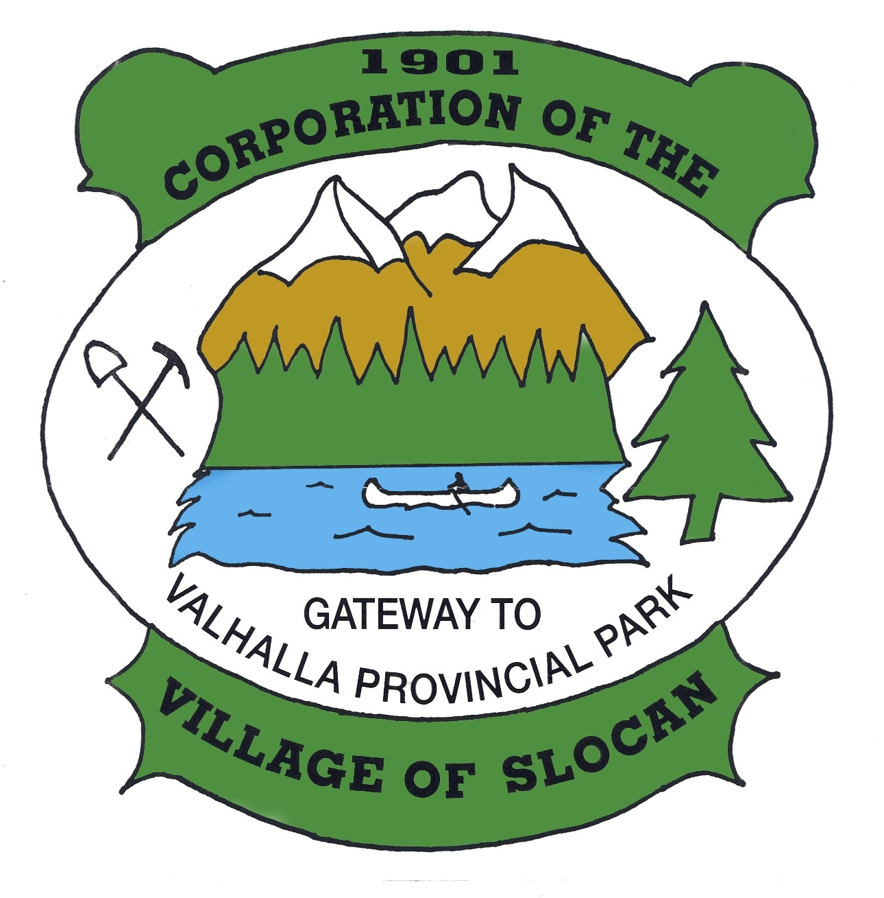


Getting to Know Your I-Pad
Wednesdays:
February 22nd to March 15th
10:00 am – 12:00 noon
Bring your iPad to the learning centre in Slocan and join in a free beginner iPad Program offered by the Columbia Basin Alliance for Literacy
Call Penny to register @
250-226-7605
Song & Rhyme at WE Graham School
Thursdays January 19th- February 23rd
10am – 11am FREE
Songs and rhymes can help calm an upset child, strengthen your relationship with your child, and help with language development. This Mother Goose program teaches parents and young children songs, rhymes, finger play, and oral stories, in a fun, active circle. Babies & preschoolers welcome. Snack provided!

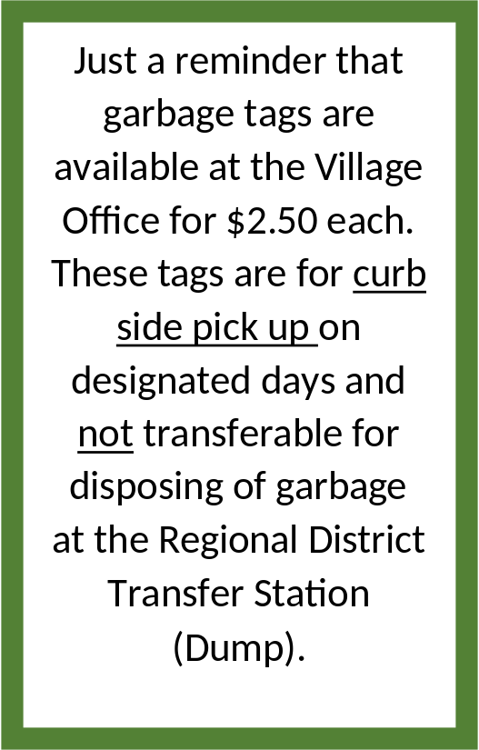

~ LEGION EVENTS ~
Sunday Music Jams: 3:00 - 7:00
Friday Night Dance: February 10th & 24th,
8:00 – 10:00 pm, $5.00 cover
Texas Hold ‘em: February 18th, 30$ buy-in, 6:30 Sharp!
Tickets @ Mountain Valley Station or Call 250-355-2672 to reserve
The Legion Welcomes Members and Guests!



Board of Variance
The Village of Slocan is looking for an applicant to fill a vacancy on the Board of Variance. Applications for this volunteer position will be accepted at the Village office. Please call for more information. 250-355-2277

Seniors Introduction to Fitness
On Saturday, February 25th the Slocan Fitness Centre and Pacific Sport are hosting a fitness seminar for seniors. Our certified trainer from Pacific Sport Columbia Basin will cover myths about activity and aging, building an exercise plan, how to stay motivated, exercise demonstrations and a fitness centre tour. Please bring clean shoes, water and wear comfortable, loose clothing. Register at the Slocan Village Office Monday through Thursday,
the cost is $10.00 per person (NON-REFUNDABLE)
We will meet at the Slocan Legion at 9:00 am and move to the Slocan Fitness Centre
afterwards to learn safe use of fitness equipment.
For more info e-mail Michelle: morellimichelle@hotmail.com

Regional District of Central Kootenay:
FLOODING
In the Kootenays, snowpack and weather-related events are a common occurrence in the spring. Residents are responsible for having a plan, as well as the tools and equipment necessary to protect their homes and themselves. In the event of a flood emergency, please utilize the following resources:
- Tune into local radio stations for evacuation alerts and sand bag locations
- Call 24/7 Emergency Reporting Number
1-800-663-3456
- Report flooding to your local RDCK Emergency Coordinator Terry Warren (Nakusp & Slocan Areas) 250-265-1920
- Check flood updates, info, and levels at www.emergencyinfobc.gov.bc.ca
For local RDCK Flood/Freshet information news releases go to www.rdck.bc.ca


ECONOMIC DEVELOPMENT STRATEGY

In 2016, the Village submitted a joint application to the Rural Dividend Fund with the Villages of Silverton, New Denver, and RDCK Area H, and was approved for funding. The project involves recruitment of a consultant and creation of an Economic Development Strategy specific to our region. Part of this process is community engagement - We encourage residents and stakeholders to attend this
public meeting:

Thursday, February 23rd, 2017
6pm – 8pm
Slocan Legion Hall

CBT Community Initiatives:
Public Input Meeting

Persons having interest in reviewing the applications for the 2017 Community Initiatives and Affected Areas
Grant Program are invited to attend:

Community Input Session
Monday, April 3rd, 2017
5:00 p.m. at the Village Office

Congratulations to
Linda Hicks on becoming Slocan’s new Post-Mistress! It’s always such a pleasure to see your smiling face and helpful attitude in the heart of our Village!

VILLAGE OF SLOCAN
MEETING NOTES: February 14th, 2017

, 2016
- Council granted permission to the Slocan Valley Historical Society, to install a display case in Council Chambers to showcase artifacts/archives. The Society will coordinate with Village staff to discuss the logistics.
- The Historical Society submitted a request to complete a Historic Walking Tour in the Village. The Tour would involve placement of interpretive signage, creation of a brochure, guidebook, and text/audio files for download. Council approved the project, and awarded the Society a $5,000 Community Development Grant. The Society will coordinate with Public Works for placement of the signs.
- The Slocan Community Initiatives Grant Program (CIP/AAP) Public Input Meeting was scheduled for Monday, April 3rd at 5:00pm. Applicants will be invited to give a 5-minute presentation on their project and answer any questions.
- The Village will once again collaborate with the RDCK to participate in Local Government Awareness Week, to be held during the week of May 15 – 21, 2017.
- Council approved expenses for the CAO to attend the LGMA Joint Chapter Meeting in Creston, BC on March 29 – 31, 2017.
- Councillor Jean Patterson was appointed as Slocan Council Representative, to participate in the Community Planning Group for the Columbia Basin Alliance for Literacy (CBAL).
- A proposal was received to paint a mural on the Kiddie Park washroom building. The proposal included a detailed concept drawing, artist statement, bio and budget. The mural would be funded solely by the artist via grant funding. Council approved the proposal, and if funding is received, the mural will be completed this summer.
- Council will send a letter to Stephanie Whitney, newly-appointed Fire Chief for the Winlaw Department, congratulating her on the new position.
- A report was received, updating Council on the latest progress of the Rural Dividend Project. A consultant has been hired and public engagement sessions are due to commence, to assist with the Economic Development Strategy for our region.
- Staff and the Mayor will meet to discuss, coordinate, and draft an ad for the Kootenay Business Magazine.
- Council agreed to sponsor the Slocan Legion’s Legacy Grant application, to repair/replace hall doors and weather-stripping.
- Council agreed to sponsor the Spirit of Slocan’s CIP/AAP Grant Application to beautify the Cenotaph area at the Wellness Center grounds. This is Phase 1 of a 3-phase beautification project.

2016 CENSUS RESULTS ARE NOW AVAILABLE ONLINE!

http://www12.statcan.gc.ca/census-recensement/index-eng.cfm
2017 UTILITY BILLING

Pease be advised that the 2017 Utility Bills are due March 1st. All Accounts with a balance after that date will have a 10% penalty as of March 31st. Unpaid balances on Dec. 31st will transfer to taxes.
Property taxes are scheduled for mailing in May 2017 –
Due date: Tuesday, July 4th, 2017.
SLOCAN VALLEY LEGACY FUND
2017 GRANT APPLICATIONS:

Interested in getting a grant from the Slocan Valley Legacy Fund? The grant application form and eligibility guidelines are available online: www.slocanvalleylegacy.com/grants-2/
This year they are distributing $12,000 total with a maximum of $4,000 per group. The deadline is March 10, 2017.

The summer season will soon be upon us, the Saturday Market in Slocan is now looking for volunteers and vendors for the 2017 season. We may have a new location, so pre-registration and payment to reserve your space is required for this year’s season! Space is limited, so don’t miss out on your opportunity to take part.
We have a fantastic line up of activities to come, and a night market is planned once a month. So be part of this great event that will happen every Saturday this summer. To reserve your space, or sign up to be a volunteer please contact
Gail at gailmorris63@gmail.com or visit the Facebook page:
Slocan artisan and farmers market

ATTENTION FITNESS CENTER USERS
The Fitness Centre WILL BE CLOSED
From 8:00am to 12:30 pm on Saturday February 18th and Saturday March 25th
for two organized fitness workshops. You must register and pay a $10.00 fee in order to attend these events. Sign up at the Village Office Monday through Thursday. There will be certified instructors from Pacific Sport Columbia Basin.
ELECTRONIC PAYMENTS

We remind residents that payments for property taxes and utilities can be processed through online banking! The service is not yet available through
some financial institutions, but those
who bank with a credit union or BMO will have full access immediately.
When creating the Village as a vendor, please do not include the zeros with account numbers. For any assistance with electronic payments, feel free to contact the Heritage Credit Union at 250-226-7212.

2017/18 Columbia Basin Trust (CBT) Community Initiatives (CIP) and Affected Areas (AAP) Funding Programs

The CIP and AAP are funding programs designed to help address the needs of Basin communities.
The programs are flexible and able to accommodate individual processes and incorporate community-based
funding decisions to better meet local priorities.
If you have a project proposal, come to the office and pick up a package or visit:
http://rdck.ca/cip-aap
DEADLINE: Tuesday February 28th, 4:30pm PST
Applications may be submitted to the Village Office, online, or to the RDCK:
Attn: Judy Madelung, RDCK, PO Box 590, 202 Lakeside Drive, Nelson BC, V1L 5R4
Please direct any questions to jmadelung@rdck.bc.ca or fax (250) 352-9300


RAIN BARREL INITIATIVE

Rain barrels are becoming a popular household item as people start to consider water conservation and local food production. The Coca-Cola Company has started to repurpose their syrup barrels and turn them into rain barrels. The Village has been in contact with Coca-Cola and have 100 rain barrels available to initiate this project in our community! Each barrel costs $50.00 and will be cleaned and retro-fitted to be used as a rain barrel. After you purchase your rain barrel, it is suggested that it be put on a stand under the existing rain gutter spouts on your house.
Please call the office to reserve your rain barrel - The Village only has 35 left to offer!
We are pleased to become proactive with water conservation!
250-355-2277info@villageofslocan.ca

