. 
2016 Council Meeting Schedule
October 11 November 14 December 12

THE CORPORATION OF THE VILLAGE OF SLOCAN
Box 50, 503 Slocan Street
Slocan, B.C. V0G 2C0
Ph: 250-355-2277 Fax: 250-355-2666
info@villageofslocan.ca
SEPTEMBER 2016
OFFICE HOURS:
Monday to Thursday from
9:00am to 4:00pm
(Closed from 12 noon to
1:00pm for lunch)
Closed on Fridays.

The Village of Slocan is putting a call out to residents that are
interested in the Rain Barrel Initiative

Rain barrels are becoming a popular household item as people start to consider water conservation and local food production. The Coca-Cola Company has started to repurpose their syrup barrels and turn them into rain barrels. The Village has been in contact with Coca-Cola and have 100 rain barrels available to initiate this project in our community! Each barrel costs $50.00 and will be cleaned and retro-fitted to be used as a rain barrel. After you purchase your rain barrel, it is suggested that it be put on a stand under the existing rain gutter spouts on your house.
Please call the office to reserve your rain barrel - The Village only has 100 to offer!
We will also advertise in other communities throughout the area to see who else has interest.
We are pleased to become proactive with water conservation!
250-355-2277info@villageofslocan.ca

SPRINGER CREEK
RV PARK & CAMPGROUND
For reservations or information:
May – Oct: 250-355-2266
springr@telus.net

WINTER IS THE BEST TIME TO TEST FOR RADON!

The Village Office has 90-day radon test available for $15 in you are interested in testing your home! For more info on radon, please visit www.radonaware.ca

FREE VEHICLE REMOVAL

The week of October 17th, the Village will once again be offering FREE vehicle removal. If you are interested in participating, please contact the Village Office to register. We will require the make, model, colour and license plate # of your vehicle (unlicensed vehicles will also be accepted). Please remember to move your vehicle onto the Village Boulevard on your scheduled day of pick-up.
This program was initiated in response to Village beautification and in preparation for winter snow removal.
250-355-2277
THERE IS NO COST TO VILLAGE RESIDENTS FOR THIS SERVICE.

Become a Volunteer Fire Fighter!
At the Slocan Volunteer Fire Department, there are many various jobs besides fighting fires. These include rope rescue, first responder, motor vehicle incident response, driver, on-scene equipment assistant, and administration. Previous experience is not necessary, and required personal protective equipment and training are provided for free. Help save lives and homes in our community!
For more info contact Deb Burnett 250-352-8154 dburnett@rdck.bc.ca
or Slocan Fire chief John Gates 250-355-2945 slocanvfd@rdck.bc.ca.

CALL FOR VOLUNTEERS!!!!

Slocan Community Library needs volunteers! Your village library is run completely by volunteers; however, every once in awhile, we need to replenish our numbers so that we can serve the community adequately. It is a wonderful place to spend a few hours serving interesting and delightful patrons.
If you are interested, please email – dgole@telus.net

Smoke & Carbon Monoxide Alarm RECYCLE Program
Fire prevention week is just around the corner! While you are checking your smoke and carbon alarms to be sure they are not out-dated or expired. There is a recycle drop-off at no cost to you at Nelson Home Building Centre, 101 McDonald Dr. in Nelson (by the airport).
Mon-Fri 7:00am-5:30pm | Sat. 8:00am-5:30pm | Sun. 10:00am-4:00pm

SLOCAN HISTORICAL SOCIETY INVITES YOU TO KEEP HISTORY ALIVE
The Society is undertaking a number of initiatives including: installing interpretive signs at historical sites in the Village, developing a walking tour, publishing a book, expanding its website, hosting a presentation this fall on Slocan Valley sawmills, and creating a logo. The Society would like Valley residents’ ideas on a logo concept. Submit your logo idea by September 30th to jaj@netidea.com. The winner will receive two books on local history!

JCP: Tourism Enhancement Project Job Posting
In May 2016, the Village of Slocan began their JCP Tourism Enhancement Project Phase 2 which involves upgrades to the RV Park and Waterfront. As this retraining program offers opportunity for participants to gain skills to better obtain employment, participant intake is perpetual. We are pleased to announce that 2 of our 4 JCP participants have gained employment, and we are now recruiting for 2 new participants.
Applicants must currently be receiving EI benefits or have received EI benefits in the last three years.
$537/week, 7 hours per day, 5 days per week
Should have some experience with construction and/ or demolition and be able to operate tools/equipment required to complete the project. Interested applicants are asked to contact their nearest WorkBC office:
KCDS (Nelson 250-352-6200 or Castlegar 250-265-3318)
Arrow lakes Community services 250-265-3318

The Slocan Valley Seniors Housing Society (SVSHS) is on a campaign to raise funds to build an affordable seniors housing complex in the Village of Slocan. I am a member of the Board of Directors of SVSHS. http://svhousing.ca/
There will be a fund-raising “Hike or Bike for Housing” event taking place September 30th, October 1st, 2nd, 2016. I will bike 95K to raise funds by pledges and online donations.
Find my personal website here:
https://www.canadahelps.org/en/charities/the-slocan-valley-seniors-housing-society/Hike-Or-Bike-For-Housing/on-track-for-seniors-housing/
Please consider contributing, help me help my community! Let’s get on TRACK for Housing!
Don Currie 250-355-2669

A Great big thank you to the fitness centre committee
A big thank you to the Fitness Center Committee for revitalizing the Gym and the exterior of the Wellness Center (entrances) with a fresh coat of paint!
Your dedication is greatly appreciated by the residents of the Village!
UPCOMING FLU SHOT CLINIC:
Wednesday, November 9th at the
Slocan Health and Wellness Center
More info in October
VILLAGE OF SLOCAN
MEETING NOTES: September 12, 2016

, 2016
- Council approved the Slocan Legion’s application to the LCLB, to amend their licensed area to include the outdoor patio
- A request was denied by Council, to vary the Zoning Bylaw to allow for a shipping container to be placed on a residential lot. Two properties in Slocan will be asked to remove their shipping containers in a timely manner. Residents are reminded that shipping containers are not permitted on residential lots.
- Council will support the Unity Music Festival 2017 in principle, and will assist with their application to the Canada Heritage Grant Fund.
- The Village of Slocan Zoning Amendment Bylaw was given third reading and final adoption.
The Village of Slocan OCP Amendment Bylaw was given third reading and final adoption.
Both amendment bylaws were required to facilitate the Slocan Valley Seniors’ Housing Society’s development application to construct a 12-unit seniors and affordable housing complex in the Village.
- The SVSHS Development Permit Application was received by Council – the Society will be directed to amend their application to vary the on-site parking requirements as set out in the Zoning Bylaw. The Society will also be directed to proceed the investigating a parking lease or license agreement with the Village, to allow for parking spaces off-site on Village land.
- The PW Supervisor reported that YRB has proposed to offer Slocan grinds-paving at no cost to the Village. Staff is proposing to have the grinds laid from the end of Main Street and out into the boat launch parking area. This will assist with dust control. Council will schedule a special meeting to discuss the proposal further, and that the Rail Trail Society be invited to attend.
- Fall Clean-Up Week will be held October 17th – 20th. Collections are limited to organic material only. The Village will once again be offering free vehicle removal.
LEGION EVENTS
Friday night Dance Sept 23rd October 7th & 23rd
Learn to tango, cha cha, waltz or chatisse!
Sunday Music Jam, 3 – 7pm
September 17th Texas Hold Em $30, buy-in 6:30 sharp

The following property will be sold at the Annual Municipal Tax Sale on Monday, September 26th at 10am, at the Village of Slocan, Council Chambers, unless the Delinquent Taxes with interest are paid prior to the sale:

ROLL# 129010
PID: 028-518-721
Lot 20, Block 16
Plan NEP496, DL 292
Ward Avenue, Slocan

Property transfers resulting from Municipal Tax Sale are subject to tax under the Property Transfer Tax Act.

DOG TAGS & POOP BAGS

Funds collected from purchased tags go directly back into the cost of purchasing dog posts and poop bags. Thank you for keeping our town clean!
If you haven’t done so already,
please come to the Office to purchase your 2016 tag, it’s not too late!

NOTICE OF 2016 TAX SALE
Pursuant to Part 11 of the Local Government Act, all Local Governments must conduct an Annual Municipal Tax Sale – a sale by public auction – of each parcel of real property on which taxes are delinquent. If property owners have outstanding delinquent balances as of
10am on Monday, September 26th, 2016,
their property will be listed and sold in the public auction. If applicable, a list of all tax sale properties will be advertised in advance.
INTERGENERATIONAL COOKING CLASS
We welcome people of all ages to join WE Graham Community Service Society and Columbia Basin Alliance for Literacy for free fun cooking classes. Traditional, contemporary, and international recipes.
Starts Thursday, September 29th 5:00-7:00pm, and continues every other Thursday! (Oct.13&27, Nov. 10&24, Dec.8) at WE Graham Community Youth Centre. Call Penny 250-226-7605 to register.
Annual Household Hazardous Waste Round-Up!
Time again to clean out your garden shed, garage and under the kitchen sink to safely rid your home of toxic chemicals such as pesticides, oils, cleaners, and unknown liquids! There is no cost for the hazardous waste disposal. For more information, please visit the RDCK website www.rdck.ca
for a list of acceptable waste.
Castlegar Community Complex - Sat. September 17, 2016 - 11:00am-2:00pm
Silverton Public Works Yard - Sun. October 2, 2016 - 11:00am-2:00pm

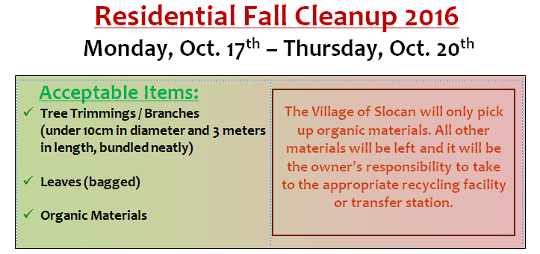
Residents are requested to place any organic materials for pickup on the boulevard where you would normally place your garbage can. Any items placed on the boulevard after October 20th will not be removed and the home owner will be responsible for disposing of the materials.

2016 CENSUS
According to Statistics Canada, Canadian’s response rate of 98.4 percent to the 2016 census is the best ever recorded, with active participation by 9 out of every 10 households.
These impressive results will yield high quality information for virtually all communities across Canada. Statistics Canada now shifts its focus to dissemination with a first data release on February 8th, 2017, launching an accelerated release schedule that will provide Canadians with all census date within
18 months of collection.

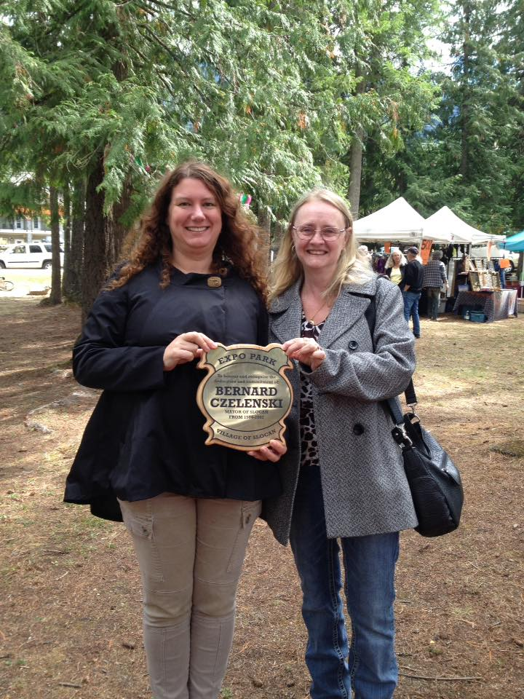
Thank you to everyone who participated in the Slocan Labour Day Parade and Celebration! A great big thank you to all the volunteer committees and local residents who assisted with planning this event. The event was well attended and enjoyed by all.

The Village would like to thank Bernie Czelenski, former Mayor of Slocan, for creating such an amazing space for residents to enjoy, for years to come.

PHOTO: Mayor Jessica Lunn presents a plaque to Debbie Gordon-St.Thomas, in memory of Bernie Czelenski.

