. 

THE CORPORATION OF THE VILLAGE OF SLOCAN
Box 50, 503 Slocan Street
Slocan, B.C. V0G 2C0
Ph: 355-2277 Fax: 3552666
info@villageofslocan.ca
JUNE 2016 NEWSLETTER
OFFICE HOURS:
Monday to Thursday from
9:00am to 4:00pm
(Closed from 12 noon to
1:00pm for lunch)
Closed on Fridays.

RESIDENTS ARE ASKED TO BURN RESPONSIBILITY

Please check By-laws, restrictions and permits before having a fire. As well, the Provincial Government has the Open Burning Smoke Control Regulation. Please keep in mind:
- Type of Material to burn. • The size of the area to burn.
- Wind direction and strength • Establish fuel/ fire breaks
- Fire Suppression • Monitor the fire at all times.
- Ensure the fire is extinguished

If the fire spreads beyond your control, call the local fire department.
http://www.env.gov.bc.ca/epd/bcairquality/topics/backyard-burning.html
http://bcwildfire.ca/Restrictions/BackyardBurning.pdf

2016 Council Meeting Schedule
July 11August 8 September 12 October 11 November 14December 12


NOTICE OF PROPOSED DISPOSITION:
Public notice is hereby given that the Village intends to proceed with the disposition of land legally described as Lots 13-20, Block 22, in the Village of Slocan, by means of long-term lease. The lands will be leased to the Slocan Valley Seniors’ Housing Society for the development of affordable housing with a focus on seniors. The consideration
to be received for the disposition is $5.00. Council will give final consideration at
their regular meeting of July 11th.
Written comments regarding this matter will be received until 4pm on Thursday,
July 7th, 2016.

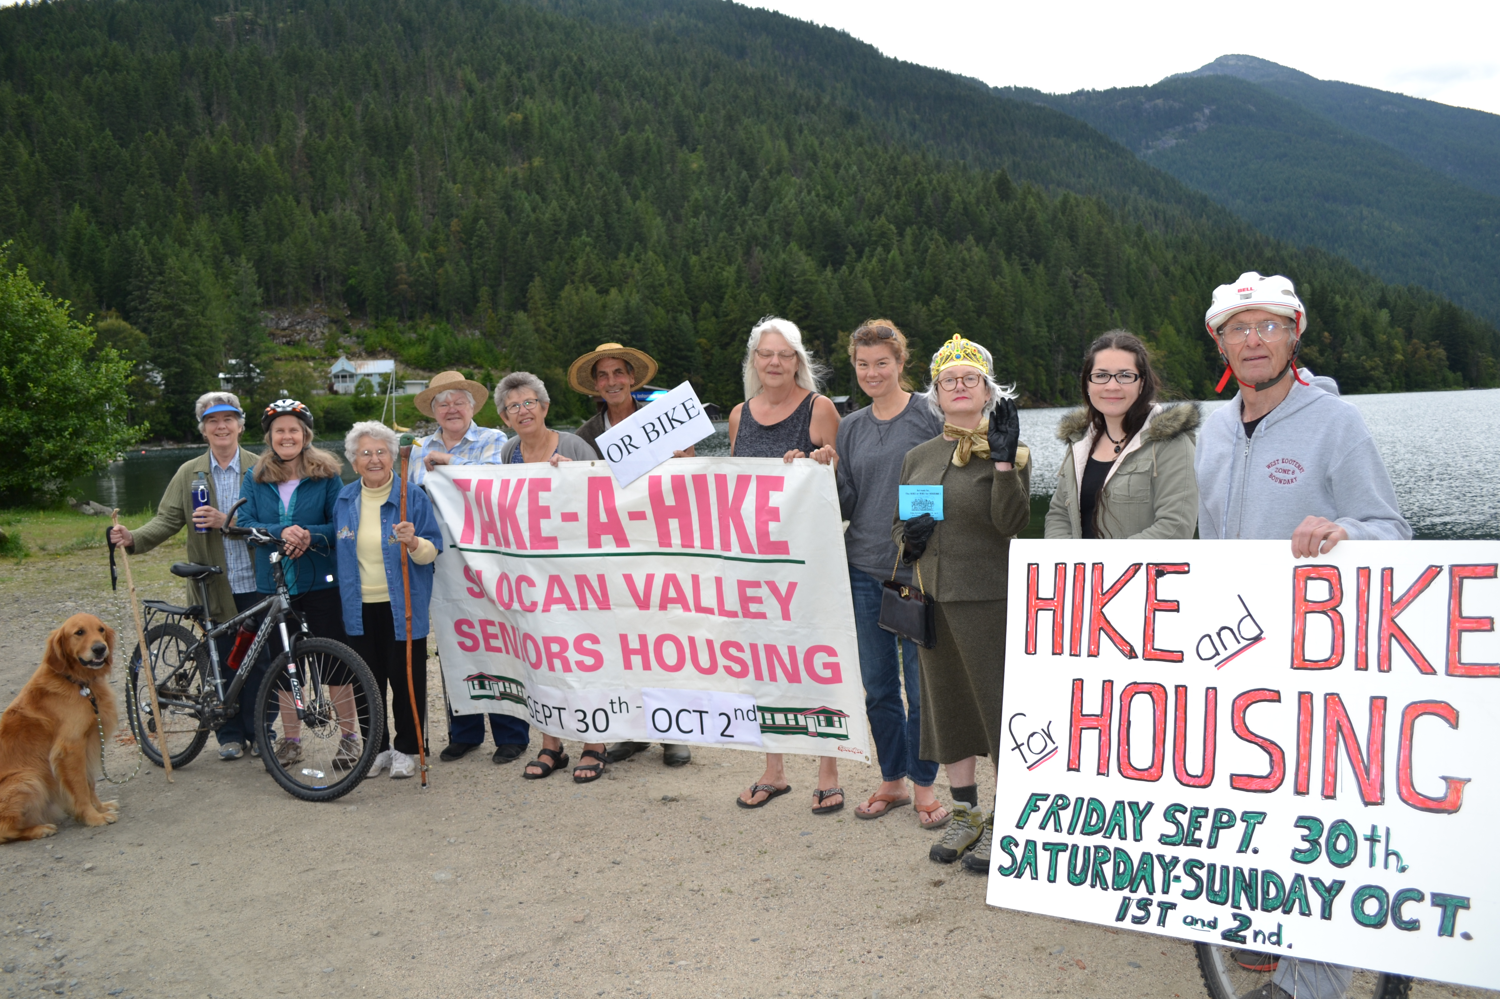
COME ONE COME ALL, TO A MARKET THAT HAS IT ALL.. SLOCAN ARTISAN/ FARMER’S MARKET

Every Saturday (except when it rains) starting June 4, 2016 – September 3, 2016, 10am – 2pm

Held at the top bench, of EXPO Park. Fun for the whole family, with a kid’s zone, day classes in the sunshine, live music, creative themes running all summer.

New Vendors Welcome!!!!!!




EXPO PARK CELEBRATIONS
SEPTEMBER 3RD, 2016

IN CO-OPERATION WITH THE SPIRIT OF SLOCAN COMMITTEE
AND THE SLOCAN SATURDAY MARKET GROUP.

CHECK OUT UPCOMING NEWSLETTERS AND FLYERS
FOR MORE EVENT INFORMATION!!

We did it then and we'll do it again! Eighteen years ago an epic 233 km. walk-a-thon raised $25,000 to help build Passmore Lodge. Now we plan to do the same for seniors' housing in the Village of Slocan. For three days, from Sept. 30 - Oct. 2, we'll hike or bike on the Slocan Valley Heritage Rail Trail with all funds going to help build 12 units of affordable rental seniors' housing in the heart of the village.
At least one of the original hikers, Lydia Kania, who was 72 then and 91 now, is already in training with the help of a walking stick carved by Don Munro, another of the early trekkers.
Hikers and bikers set for the 2016 challenge are (l-r) Slocan Valley Seniors' Housing Society board members Penny Tees (with Rudy, the dog), Lynnda Moore, and Lydia Kania, who covered every step of the 10-day route in 1998; Slocan councillors Jean Patterson and Madeleine Perriere; Corky Evans (who hopes to keep up with Lydia); Slocan Fitness Club members Ruby Powers and Michelle Morelli; special guest Betty Windsor (in understated crown, British hiking tweeds, and handbag), Village CAO Michelle Gordon; and star athlete and housing society board member Don Currie, ready to rev up the community for the special event of the autumn! Organizers plan a great send-off for participants and community celebrations to welcome them at the end of the each day's route. In the middle of the photo, the big white banner is pure vintage: retrieved from the Passmore Lodge attic, it was changed from the 1998 Take-a-Hike dates to reflect the Hike and Bike dates for 2016. For more information or to get involved, email ritamoir@columbiawireless.ca Pledge sheets, brochures and many more details will be available soon! Everyone is welcome to join in, raise funds and be part of another epic Valley event. It's gonna be fun!

The Slocan Fitness Centre will be undergoing a facelift this summer!

The facility will be getting a new look and a fresh coat of paint. A special shout-out to the Columbia Basin Trust for supporting our project, and to Maegan Deighton for volunteering her design expertise.

THE FITNESS CENTRE WILL BE CLOSED FOR PAINTING FROM AUGUST 14TH THROUGH AUGUST 16TH.
SORRY FOR ANY INCONVENIENCE.


SPRINGER CREEK
RV PARK & CAMPGROUND
IS NOW OPEN FOR THE SEASON!
For reservations or information:
May – Oct: 250-355-2266 | springr@telus.net

VILLAGE OF SLOCAN
MEETING NOTES: June 13th, 2016
      - Council met with the Curling Club Executive Committee to discuss current and future plans for the building.
- Gail Morris of the Saturday Market Committee, in partnership with the Spirit of Slocan Committee intend to host a car show at the ball field on Saturday, August 13th from 10am – 4pm. Council will give final approval at their next meeting.
- The Spirit of Slocan Committee & Saturday Market will host a Labour Day Celebration on September 3rd. Portions of Harold Street and Giffin Avenue will be closed between 11am and 12pm for the parade.
- The Village will purchase a plaque, to be placed at the ball field Expo Field during Labour Day Celebrations, in dedication to Bernard Czelenski, former Mayor of Slocan.
- The 2015 Annual Report was received by Council and is now available for public inspection. Council will give final consideration to the Report at a Special Meeting on June 27th, 5:00pm.
- Council received the 2015 CARIP Report
- Council formally noted support for the Seniors’/Affordable Housing Complex in Slocan and resolved to proceed with the property disposition by means of long-term lease.
- Counil supported a joint application to the Canada 150 Grant Fund with the Legion, for the purpose of completing recommended and mandatory upgrades to the Legion Hall.
- The Variance Application, to vary front and exterior lot lines from 15 to 12 feet at 1119 Arthur Street, was approved. Owners plan to construct a house and garage on the two lots.
- The Mayor will attend the Silverton July st Celebration.
- The Fitness Center request was approved for installation of security cameras in the Wellness Center hallway. A sign will be posted to notify visitors.
- The Slocan After School Sports & Art Initiative requested plywood sheets to be placed at the tennis court. Councillor Van Bynen and Public Works will assist.
- The Mayor will attend the SD8 Facilities Plan Meeting at the Board Office on June 17th.
- Council approved the Permissive Tax Exemption Policy No. 2016-040 as presented.

We are pleased to announce the acceptance of our JCP Application to complete upgrades to the campground and waterfront! This is a $120,000 project, funded by the Government of Canada and Province of BC, with $40k worth of in-kind and cash supports. Thank you to those who submitted letters of support and encouragement!

We are also pleased to share that grant funding ($10,000) has been approved for our Cemetery Mapping Project! The scope of this project is to develop an up-to-date digital cemetery database and cemetery web-mapping and management application, for both internal and external users. Village staff can utilize this system to track, plan burials, and update records as needed. Members of the public can log on to search for burial location of a loved one or for genealogy research. Ground penetrating radar can confirm location of unknown burials and solidify historical records. Thank you to Columbia Basin Trust and the RDCK!

The Village has also been approved for a grant to hire a summer student, to assist with Public Works duties.
DOG TAGS & POOP BAGS

Funds collected from purchased tags go directly back into the cost of purchasing dog posts and poop bags. Thank you for keeping our town clean!

If you haven’t done so already,
please, come to the Office to purchase your 2016 tag, it’s not too late!

KNOTWEED
Knotweed is an invasive weed that is present in Slocan, with many infestations on personal property. Please take caution NOT to remove this plant without instructions on how to do so. Information is available at the office. Residents would recognize this plant as looking similar to bamboo. We are actively working on a solution for treatment. We will keep everyone posted. More info can be found at:
http://ckiss.ca/species/invasive-knotweeds/

Applicant | Project | Approved:
BC SPCA – Nelson Branch | Spay/Neuter Initiative | $300
Health Arts Society | Concerts in Care | $100
KAAP | Spay/Neuter Initiative | $750
Slocan Legion 276 | Kitchen Exhaust System/Kitchen Reno | $12,000
Technical Rescue Society | Rope Rescue Training | $2,000
Slocan Community Library | Library Improvements | $1,300
Slocan Fitness Center | Fitness Center Development | $1,800
Slocan Lake Stewardship Society | Strategic Conservation Framework | $1,000
Slocan Valley Cultural Alliance | Unity Music Festival 2016 | $3,419
Slocan Valley Heritage Trail Society | Vegetation Control Project | $750
Slocan Valley Seniors Housing | Affordable Seniors’ Housing Project | $10,000
White Pines Aikido Association | Children’s Bursary/Instructor First Aid | $750
World Sign Communication Society | Pocket Sized Symbollary | $250
 | TOTAL | $34,419

At the Special Meeting of Council on Monday, May 9th, Council had the opportunity to revisit the CBT Grant Applications, and have awarded funding as noted. The list of allocations will be sent to the RDCK for cheque distribution. All comments/ questions may be directed to Judy Madelung, RD Grants Coordinator, at 250-352-8170.

NOTICE OF ANNUAL MEETING

ANNUAL MUNICIPAL REPORT PUBLIC MEETING
MONDAY, JUNE 27TH at 5:00pm
Slocan Village Office, Council Chambers
503 Slocan St.

The Village of Slocan would like to invite the public to attend a Special Meeting of Council, for the purpose of giving consideration to the
2015 ANNUAL MUNICIPAL REPORT

Council will consider comments from the public regarding the Report; those who are unable to attend the meeting are invited to submit their comments by mail, e-mail or fax before 4:00pm on Thursday June 23, 2016.

The 2015 Annual Report is available for inspection at the Village Office during regular office hours
(Mon – Thurs, 9am – 4pm) or by visiting www.slocancity.com

LEGION EVENTS

Sunday Music Jams, 3 – 7pm

The Legion Dance Night is the 1st & 3rd Friday of June, July and August, 2016. Admission $5.00 8 – 10pm.

June 19^{th,} Legion Community Thank You BBQ celebrating Legion Week.

June 25th, Legion Pig Roast and Dance. Live Music. Tickets $20.00

Please remember to come to the Office and sign your Home Owners Grant for 2016. Even if you are not paying until later, doing this before the 4th of July will lower the penalty that is imposed that day. If your bank is paying your taxes it is YOUR responsibility to sign for your Home Owner Grant before the 4th of July or you will have a 10% penalty added to your bill that you will have to pay to clear your account.
Thank you, The Village Office
The Fire Department, 1st Responders & Technical Rescue Society wish to thank everyone who participated in this year’s 2016 Fishing Derby.



