. 

THE CORPORATION OF THE VILLAGE OF SLOCAN
Box 50, 503 Slocan Street
Slocan, B.C. V0G 2C0
Ph: 355-2277 Fax: 3552666
info@villageofslocan.ca
MARCH 2016 NEWSLETTER
OFFICE HOURS:
Monday to Thursday from
9:00am to 4:00pm
(Closed from 12 noon to
1:00pm for lunch)
Closed on Fridays.



Monday, April 25th – Thursday, April 28th

RESIDENTIAL SPRING CLEAN-UP
*MAXIMUM: TWO PILES OF ONE CUBIC METER EACH*
Put your items in the same location you would normally put your garbage can.




Acceptable Items:
- Furniture - sofas, beds, chairs, etc.
- Domestic household items
- Garden Trimmings (must be
bundled neatly)
- Branches separated to run
through chipper (Less than 10cm in diameter)
- There is a $20.00 charge for
picking up items containing
Freon (ex: fridges, freezers)
- There is a $10.00 charge for picking
up White Goods (stoves, hot water
tanks, washers, dryers)

Unacceptable Items:
- Vehicles
- Hazardous waste - paint, fuel,
used oil, flammables, poisons,
thinners, pesticides and
fertilizers, etc.
- Oil tanks
- Tires
- Propane tanks
- Vehicle batteries

2016 Council Meeting Schedule
APRIL 11May 9June 13
July 11August 8September 12

JUST A REMINDER THAT ALL OUTSTANDING UTILITY BILLS WILL HAVE A 10% PENALTY ADDED TO THEM ON MARCH 31, 2016, PURSUANT TO THE SLOCAN FEES AND CHARGES BYLAW SCHEDULE E, SECTION 5.

TAX NOTICES WILL BE ISSUED IN MAY 2016 and are due MONDAY, JULY 4th


FREE VEHICLE REMOVAL

The week of April 25th, 2016, the Village will once again be offering FREE vehicle removal. If you are interested in participating, please contact the Village Office to register. We will require the make, model, color and license plate # of your vehicle (unlicensed vehicles will also be accepted). Please remember to move your vehicle onto the Village Boulevard on your scheduled day of pick-up. This program was initiated in response to Village beautification and in preparation for summer.
250-355-2277

THERE IS NO COST TO VILLAGE RESIDENTS FOR THIS SERVICE.

Thank you to those who have been supporting the Slocan Fitness Center!
Keep up the great work!

To keep our facility safe, please make sure the entrance door is firmly locked. Your cooperation and cleanliness is greatly appreciated.

W.E. GRAHAM COMMUNITY SCHOOL IS CURRENTLY ACCEPTING REGISTRATIONS FOR THE 2016 – 2017 SCHOOL YEAR. IF YOU HAVE A CHILD GOING INTO KINDERGARTEN OR ANY GRADE UP TO GRADE 10, PLEASE DROP BY THE SCHOOL FOR A REGISTRATION FORM OR CALL 250-355-2212.
W.E. Graham offers multi-grade classes and innovative programs. Students entering grades 7 or 8
have the opportunity to take part in the Outdoor Education Leadership Program, and grades 9&10
can apply separately for the Valhalla Wilderness Program.

“(Sports) + (Arts) = Magic!
Those are the words on the Premier’s Award for Innovation, presented to the WE Graham Community School in recognition of the After School Sport and Arts Initiative (ASSAI) at the SD8 board of education meeting in Nelson on February 23.”
- Valley Voice, March 9th, 2016 - Sheri Walsh.

Congratulations to all 31 communities across BC who receive funding through The Ministry of Sport and Cultural Development and DASH out of Vancouver. This program at WE Graham Community School is the only one of its kind in our area and all the people involved in making this happen. These people deserve our heartfelt congratulations and continued gratitude for making this program such a success and loved by so many in the area.

Congratulations and thank you again for all you do for the
children of our community!



RDCK Transfer Station
Just a reminder: The Slocan Transfer Station is open every Tuesday and Saturday from 10am to 4pm, excluding holidays. For more information, please call the RDCK at (250) 352-6665.

The CBT/CIP Public Meeting

Will be held on Monday April 25th at 5pm

Everyone is welcome to come and listen to the presentations by the applicants.

All applicants are invited to give a 5 minute presentation and answer any questions on their applications.

VILLAGE OF SLOCAN
MEETING NOTES: March 14th, 2016
“The Village of Slocan recognizes that W.E. Graham Community School is an excellent facility that has the potential to house more students from central Slocan Valley sub-region. We encourage the district to maintain status quo configuration of W.E. Graham Community School.” – Mayor Lunn

The Village of Slocan is in support of WE Graham Community School for the School District 8 facilities review.
We encourage members of the public to submit letters of support or comment to:

http://www.sd8.bc.ca/?p=3507 - Facilities Review

facilities@sd8.bc.ca – Email comment here. The more we speak out, the better our collective voice is heard.

FOR THE PUBLIC’S INFORMATION, WE HAVE SUCCESSFULLY FILLED ALL POSITIONS FOR THE SCREECH OWL ADVISORY COMMISSION AND FITNESS CENTRE ADVISORY COMMISSION.

THANK YOU TO EVERYONE WHO PUT THEIR NAMES FORWARD.
- Sally Hammond and Ann Meidinger, Directors of the Slocan Lake Stewardship Society presented to Council a brief overview of a Resource Analysis: Step #1 of an Ecosystem-based Conservation Action Framework for Slocan Lake, by Marcy Mahr, M.Sc. The report is available for viewing at the Village Office.

- The CAO provided a report on the Curling Club, moving to open meeting the building’s structural and mechanical deficiencies as noted by staff, building inspector, fire inspector, and electrical inspector. The report is available for viewing at the Village Office.

- Council approved the formation of a Western Screech Owl Lands Advisory Commission, approved the draft Terms-of-Reference, and appointed the following volunteer members: Cal Alymer, Phyllis Del Puppo, Lynnda Moore, Denise Dufault, and Leela Kapel. These new members will join Mayor Lunn and Councillor Pelletier. All member appointments to the previous Owl “Select” Committee have now been terminated.

- Council approved the formation of a Fitness Center Advisory Commission and approved the draft Terms-of-Reference and Policy. Council appointed Madeleine Perriere as the Council rep and Michelle Morelli, Don Currie, Dianne Smith, Ruby Powers, Randy Powers, Becky Mayrhofer, Ken Fominoff, and Linda Baltgailis. All member appointments to the previous Fitness Center “Select” Committee have now been terminated.

- Council authorized staff to enter into contract with the RDCK for the purpose of completing a Slocan Cemetery Mapping Project, pending grant fund approval.

- The 2016 Annual Spring Clean Up Week be held Monday, April 25th to Thursday, April 28th, 2016 and that the Village limit the amount of collected materials per household to a maximum of two piles of one cubic metre each; and that $20 Freon and $10 Non-Freon tags, for pick-up of white goods, be available for purchase at the Village Office.

- Council scheduled a public meeting for Monday, April 25th, 2016 commencing at 5:00pm, at which time CBT Community Initiative Grant applicants will be invited to give a 5-minute presentation and answer any questions on their applications.

- Council authorized all members of Council to attend the 2016 AKBLG Conference in Kimberly, BC if available to, as per the Slocan Council Conference Delegation Policy.

- Council approved the draft operating budget as presented by Colin McClure, CFO.

- A letter will be drafted to support the City of Port Coquitlam’s resolution regarding the Build Canada Grant Fund, and sent to FCM and UBCM.

- Council approved and gave 3 readings to the Fees & Charges Amendment Bylaw reflecting changes to the Campground rates. Rates will increase by 1 dollar per site, per night, and $2 coin operated shower time will be decreased from 7 minutes to 5.

SPRING AUTHOR SERIES TO BEGIN AT THE SLOCAN LIBRARY

Sunday, April 3rd, 2016 @ 1pm – Nelson Miller, “Book of Cool” (2015) and Elizabeth Blakely, “Awake! A Spiritual Planner”.

Sunday, May 4th, 2016 @ 1pm - Diana Cole, author of “Sideways: Memoir of a Misfit” (2015)
REMINDER TO ALL DOG OWNERS
Please come to the Village Office to purchase your dog’s shiny new tag for 2016! Please be mindful that dogs need a pack walk with their owners to help keep them social and happy. Dogs walking without their owner, is not a welcome practice. Doggie bags are available on posts around town. Thank you for keeping our town clean!

SPRINGER CREEK
RV PARK & CAMPGROUND

OPENING DATE: Thursday, May 19th, 2016
CLOSING DATE: Monday, October 10, 2015

For reservations or information:
May – Oct: 250-355-2266 | springr@telus.net
Nov – Apr: 250-355-2277 | info@villageofslocan.ca

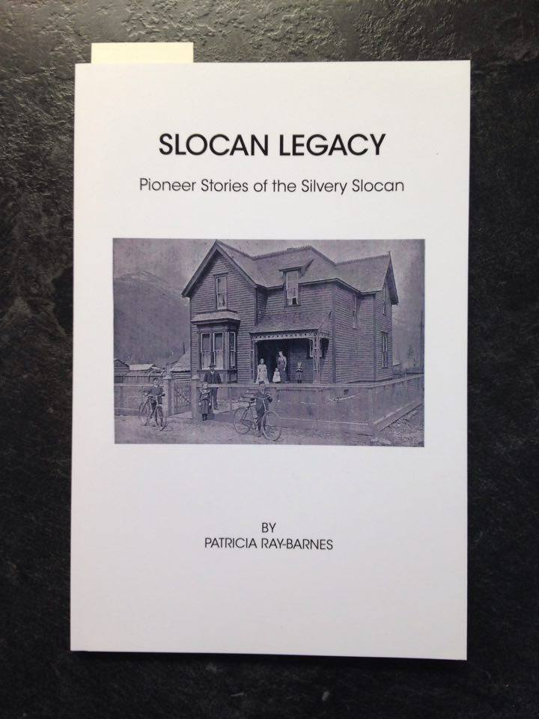
Back by popular demand; this publication is once again available at the Village Office! Thank you to the Slocan Historical Society.
“SLOCAN LEGACY”
by Patricia Ray-Barnes

SPIRIT OF SLOCAN – PARADE OF GARAGE SALES 2016
SATURDAY, APRIL 23TH, 2016 from 9am – 2pm

We invite all the local and area residents, businesses, and clubs to participate in this HUGE Sale Day! Registration of your address, which will be put on the map (Fee: $5), can be made at Mountain Valley Station by Thursday, April 21ST at noon. Maps will be handed out to all the visitors on Sale Day. Anyone outside the perimeters of the town map who wish to participate with a table may set up at the Mountain Valley Station lot (reserve space with Pat or Peggy 250-355-2245). This is prime time to get your homes, garages, and sheds cleaned out and have some fun in the process. Our new town maps now include Slocan West Road and Slocan South Road, south to Hatch Road and Gravel Pit Road, and includes Brandon. Everyone on these routes is invited to join in! Wish for good weather and a day of fun.

. . . . .Sponsors for this event “Spirit of Slocan Committee” . . . . .

2016 BUDGET AND FINANCIAL STATEMENT PRESENTATION

MARCH 21, 2016 AT 5PM
COUNCIL CHAMBERS
The Village of Slocan




