. 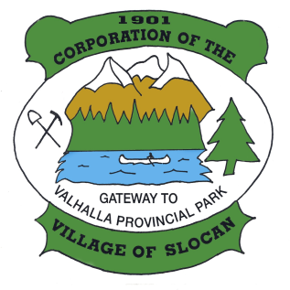

**VILLAGE VISIONS ART PROJECT**



**Students at W.E. Graham Community School have created an artistic timeline in response to the closure of Springer Creek Forest Products Mill in the village of Slocan. Village Visions is a cumulative multi- faceted art project focusing on the past, present and future of Slocan Village.**

**Thanks to the ArtStarts large project grant, and funding support from BC Art Council and Vancouver Foundation, students have been working on three aspects of this project with various artists.**

**THE PAST:**

**The Village Visions Project began with recognition of the SINIXT nation and native lands in the area. The school was invited to a Sinixt pit-house where they engaged in storytelling, music, and a walk about.**

**THE PRESENT:**

**Students are in the process of using recycled metal from the old mill site to create a large osprey sculpture (There is a large osprey nest at the old mill site). Each student designed their own feather. They created images and stencils depicting present day in Slocan. They then spray painted these onto their metal feather. The metal sculpting artist, Darren**

**Ireland, with the help of students will assemble these pieces to create a beautiful 6 feet high osprey to be displayed in the Slocan community garden. The community garden is adjacent to the school grounds.**

**FUTURE:**

**The final project will be a banner painting creation. These banners will replace the banners currently hanging from the lamp standards on Harold Street and Slocan Street in the village. (W.E. Graham School is on Harold Street) We are fortunate to have BC painter, Tina Lindegaard share her artistic talents with us! Looking forward to what the future will bring!**



**OFFICE HOURS:**

Monday to Thursday from

9:00am to 4:00pm

(Closed from 12 noon to

1:00pm for lunch)

Closed on Fridays.

**THE CORPORATION OF THE VILLAGE OF SLOCAN**

**Box 50, 503 Slocan Street**

**Slocan, B.C. V0G 2C0**

**Ph: 355-2277 Fax: 3552666**

**info@villageofslocan.ca**

**October 2015 NEWSLETTER**

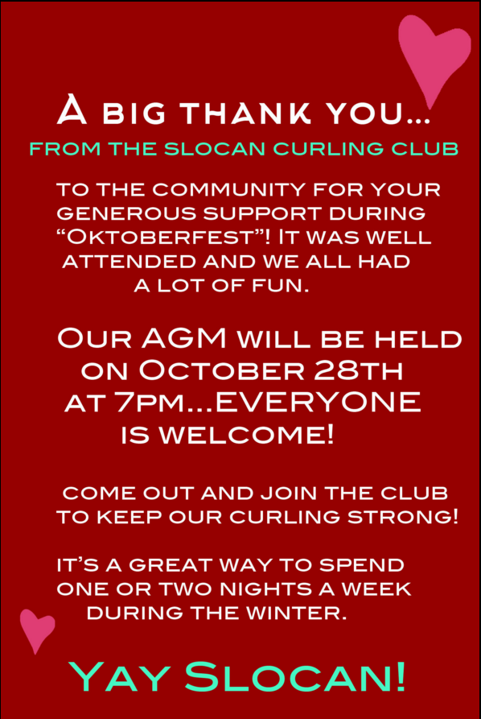

**2015 Council Meeting Schedule**

**~~June 8~~ ~~August 10~~ ~~October 13 (Tues)~~ December 14**

**~~July 13~~ ~~September~~ ~~14~~ November 9**

* **Live Music Every Sunday afternoon at the Legion – Open Music Jam. Come enjoy live music from 3:00 pm to 7:00 pm every week. Listen or join in and have fun!**
* **October 31st:  
  *HALLOWEEN DANCE – 9:00 PM – 1:00 AM at the Legion. Members and Guests Welcome! Tickets are $10 and can be purchased at Mountain Valley Station.  
  *FIREWORKS at the Ball Field! Complimentary hot dogs, hot chocolate, bonfires, costumes, and more!**

**StrongStart is up and running!**

Mondays at WE Graham school from 9-12 pm.

Tuesdays, Wednesdays and Friday mornings at Winlaw Elementary School

Thursday afternoons in Winlaw

Times at Winlaw are still being finalized

**Story Time in Slocan**

Wednesdays 10:30 – 11:00 am (starting September 30)

Slocan Community Library

Join the fun for preschool stories. All ages are welcome with separate activities for the older ones.

**Song & Rhyme**

Mon October 5 – November 23

9:00 – 10:00 am

WE Graham Community School

This is an eight week program offering a fun circle time, with songs and rhymes during StrongStart in Slocan. Come and have a healthy snack and borrow books from the CBAL parent library.



**ELECTRONIC PAYMENTS**

We are pleased to announce that residents can now pay their property tax and utility bills through online banking!

The service is not yet available through

some financial institutions but those

who bank with a credit union will have full access immediately.

When creating the Village as a vendor, please do not include the zeros with the account numbers. For any assistance with electronic payments, feel free to contact the Heritage Credit Union at **250-226-7212.**





**Slocan Community Library  
Village Newsletter  
September, 2015**  
  
Website: slocanlibrary.ca  
Facebook  
Email: [info@slocanlibrary.ca](mailto:info@slocanlibrary.ca)  
  
**Library Hours**Monday and Tuesday: Closed  
Wednesday: 10 am – 1 pm   
Storytime 10:30 – 11:15 am  
Thursday: 1 – 5 pm  
Friday: 7 – 9 pm  
Saturday: 1 – 4 pm  
Sunday: 11 am – 3 pm

Tom Wayman & Ernest Hekkanen - Sunday, October 25 at 1:00 pm

Amanda Bath - Sunday, November 19 at 1:00

**New Acquisitions**

Check out the website, slocanlibrary.ca for a listing of new acquisitions which are arriving now!

**VILLAGE OF SLOCAN**

**MEETING NOTES: October 13th, 2015**

**KALESNIKOFF LUMBER CO. LTD. – Referral Notice**

Kalesnikoff Lumber Co. is currently advertising a Forest Stewardship Plan (FSP) to cover the entire area of Arrow and Kootenay Lake Timber Supply Areas. Kalesnikoff does not intend to infringe on operating areas or break commercial arrangements, but expects to increase efficient forest planning. The FSP is a landscape level plan, focused on establishing objectives, strategies and results for conserving and protecting timber and non-timber resource values within crown lands slated for future forest management activities. Kalesnikoff Lumber invites the public to provide comment on the FSP in regards to their established FDU’s (Forest Development Units). The objective of this notice is to provide a person whose rights may be affected by the plan with an opportunity to identify areas of concern within the FDU’s, to ensure that concerns are addressed prior to development of an area of crown land allocated for Kalesnikoff’s forest development activities. Submissions can be sent to [tylerh@kalesnikoff.com](mailto:tylerh@kalesnikoff.com) by November 1, 2015.

|  |  |
| --- | --- |
| Slocan Logo | **THE CORPORATION OF THE VILLAGE OF SLOCAN**  **PUBLIC NOTICE**  **FINANCIAL PLAN ADMENDMENT BYLAW** |

Please be advised that the Village of Slocan Council invite the public to review the proposed Financial Plan Amendment Bylaw. The purpose of this amendment is to provide for adjusted revenues and expenditures for the 2015 budget year. The Bylaw is scheduled for adoption on November 9th, 2015.

Council encourages the public to review the Bylaw at the Village Office during regular business hours and will be collecting submissions until Monday, November 2, 2015 at 4:00pm.

For further information, please contact the Village Office at 250-355-2277

**ART THERAPY OPEN STUDIO DROP-IN   
FOR ADULTS**

The after school open studio is an art therapy group open to adults. All are welcome to drop in for a relaxed, supportive atmosphere for expression in various artistic mediums, social connection and an opportunity to share creativity, inspiration and conversation.

Every Tuesday from 3:30 – 5:00 at the Slocan Youth Center  
250-355-2484

**Board of Variance**

There is a vacancy on the Village Board of Variance. Applications for this Volunteer position will be accepted at the Village Office until Monday November 2nd at 4pm.

For more information please call 250-355-2277.

* CFO Colin McClure presented the quarterly financial report for the period ending September 30th, 2015.
* Patricia Dehnel, Planning Manager, presented a report to Council regarding the updates and status of the Micro-Hydro Project.
* John Patterson and Keith Cumming were re-appointed to the Board of Variance for a further term of three years. Staff will advertise for recruitment of a third member to fill the vacant position.
* A $750 RDCK Community Development Grant was approved for the Annual Halloween Hoot, to be held at the ball field on October 31st, 2015.
* A $150 RDCK Discretionary Grant was approved for the WEGCSS Food Bank Christmas Hamper Program.
* Council received a written claim to the 2013 Tax Sale surplus. Staff is directed to file the appropriate paperwork with the Supreme Court of BC.
* The Village will provide a letter of support to the Slocan Lake Stewardship Society for their Wild Days education program.
* A letter will be sent to WE Graham Community School students and teacher Halii Raines, thanking them for their banners and artistic visions.
* A letter will be sent to Telus thanking them for offering their services, free of charge, to hang the WE Graham Community School banners down Harold Street.
* Council introduced and gave three readings to the Financial Plan Amendment (2014-2018) Bylaw No. 643, 2015 and staff was directed to post public notice for invitation to review and comment on the Bylaw, prior to adoption on November 9th.
* The Village of Slocan Permissive Tax Exemption Bylaw (2016-2018) Bylaw No. 646 was adopted as presented.

Thank you to those who attended our Committee-of-the-Whole Waterfront Meeting on October 5th. There were many great ideas and comments brought forward which Council and staff will review in the coming months. We appreciate our residents and your opinions. Thank you!