. 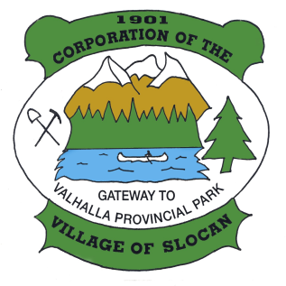

**THE CORPORATION OF THE VILLAGE OF SLOCAN**

**Box 50, 503 Slocan Street**

**Slocan, B.C. V0G 2C0**

**Ph: 355-2277 Fax: 355-2666**

**info@villageofslocan.ca**

**September 2015 NEWSLETTER**

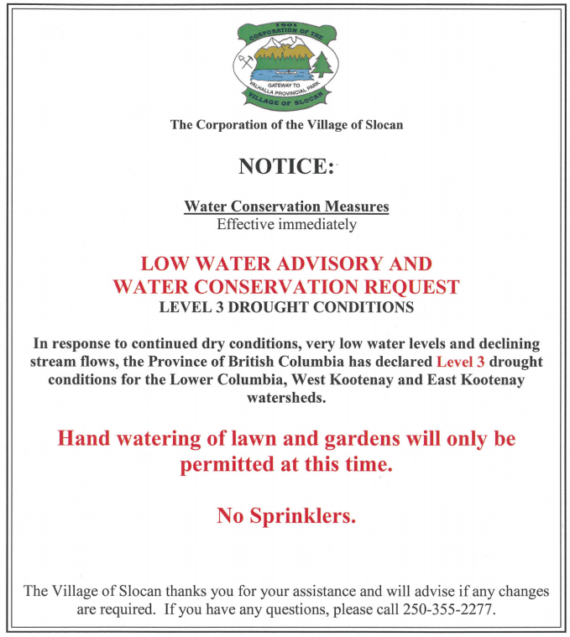





**OFFICE HOURS:**

Monday to Thursday from

9:00am to 4:00pm

(Closed from 12 noon to

1:00pm for lunch)

Closed on Fridays.

**2015 Council Meeting Schedule**

**~~June 8~~ ~~August 10~~ October 13 (Tues) December 14**

**~~July 13~~ ~~September~~ ~~14~~ November 9**

* **Live Music Every Sunday afternoon at the Legion – Open Music Jam. Come enjoy live music from 3:00 pm to 7:00 pm every week. Listen or join in and have fun!**
* **October 10 - The Curling Club’s Oktoberfest Fundraiser. Come down and enjoy music, food and loads of fun. At the Curling Club from 3:00 pm to midnight. Fun for everyone! Helicopter rides will be offered, reserve your spot now!**

COMMUNITY VOTER’S CHALLENGE

The Village of Slocan has been invited to participate in the 2015 Voter’s Challenge. The goal of this challenge is to increase voter turnout on October 19th, 2015. According to Elections Canada, approximately 62% of those aged 18 – 25 did NOT vote in the 2011 Federal Elections and the 25 – 34 age bracket was equally low. The Village wants to encourage our residents, over 18, to cast their ballots.

The organizers will calculate the percentage of voter turnout for each participating community, comparing the previous federal election and the upcoming one. The largest percentage increase wins. Prize for the winning community is to be announced.

**VOTE OCTOBER 19, 2015**

**For further information please, contact the Village Office at 250-355-2277**

**Join the Community Voters Challenge Facebook Page**.

**Federal Election Information**

**Don’t forget that the Federal Election is October 19th, 2015.**

**Register to vote now! Go to** [**www.elections.ca**](http://www.elections.ca)**, click “register” then click “start”. It will prompt you through the registration process.**

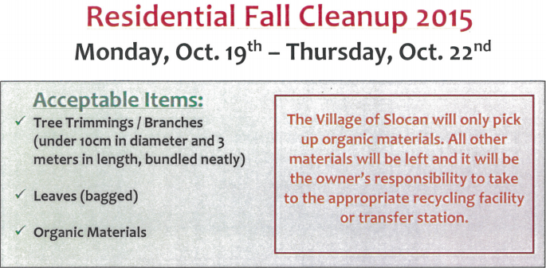

**Fall Programs**

Intergenerational food transformation/preservation class: Thursdays 4:30-7:00 pm, September 24 – October 29, W.E. Graham School. All ages are welcome at this food transformation class. Local experts will teach canning, fermentation and other cooking skills.

**Sept 24: Saurkraut and Kimchi Oct 1: Sugar free jam Oct 8: Canning**

**This is a free program offered by the CBAL and WEGSCC. Please register so there is enough supplies**.

**Song and Rhyme** – A fun circle time of songs and rhymes during Strong-Start in Slocan. Come and have a healthy snack and borrow books from the CBAL parent library. ***Will commence with Strong-Start in the fall.***

**Adult Computer Class** – Improve your computer skills and feel more comfortable managing files, using emails and the internet. All levels of experience are welcomed. ***Wednesdays; 10:00am – 12pm, September 30 – November 25, 2015.***

**Please contact Allison at 250-359-6887 to register or for more information.**



**SVSHS AGM Meeting**

The September SVSHS meeting will be held on September 23rd, at 7:00 pm. Please come at 6:00 pm for refreshments and the meeting will commence at 7:00.

It will be held at the Passmore Hall at 3650 Old Passmore Rd.

**Spirit of Christmas**

The Spirit of Christmas Tree Lighting will be at 6pm on November 29th, at the Wellness Center. Join in the fun for the commercial and residential decorating competition. Pull out your lights and start planning your brilliant display. The judging will occur during the annual carolling evening in December. More information will come in the October newsletter

.

**Slocan Community Library  
September, 2015**  
Website: [www.slocanlibrary.ca](http://www.slocanlibrary.ca)

We’re on Facebook  
Email: [info@slocanlibrary.ca](mailto:info@slocanlibrary.ca)  
  
**Library Hours**Monday and Tuesday: Closed  
Wednesday: 10 am – 1 pm   
Storytime 10:30 – 11:15 am  
Thursday: 1 – 5 pm  
Friday: 7 – 9 pm  
Saturday: 1 – 4 pm  
Sunday: 11 am – 3 pm

**Author Readings:**

**Deryn Collier** - Sunday, September 27 at 1:00 pm

**Tom Wayman & Ernest Hekkanen** - Sunday, October 25 at 1:00 pm

Amanda Bath - Sunday, November 19 at 1:00

**New Acquisitions:**

Check out the website, www.slocanlibrary.ca for a listing of new acquisitions which are arriving now!

**VILLAGE OF SLOCAN**

**MEETING NOTES: September 14, 2015**

**FREE VEHICLE REMOVAL**

The week of October 19th, 2015, the Village will once again be offering FREE vehicle removal. If you are interested in participating, please contact the Village Office to register. We will require the make, model, colour and license plate # of your vehicle (unlicensed vehicles will also be accepted). Please remember to move your vehicle onto the Village Boulevard on your scheduled day of pick-up.

This program was initiated in response to Village beautification and in preparation for winter snow removal.

***250-355-2277***

***THERE IS NO COST TO VILLAGE RESIDENTS FOR THIS SERVICE.***

**Community Directed Youth Fund Seeks Directors**

The CDYF is seeking community members to join a board that will oversee the purchase, maintenance, and administration of the Youth and Community bus. Potential board members can be anyone ranging from youth to adults. Preference will be given to those who have experience with planning public transit, public transit users, local business owners and youth, though anyone is welcome to connect and apply. Please send an email introducing yourselves to [cdyfcoodinator@gmail.com](mailto:cdyfcoodinator@gmail.com) with the subject line CDYF Board or call Andi Grace @ WEGCSS at **250-355-2484**

**Village of Slocan Owl Walk Grand Opening**

**October 2nd**

**If you see a picture of a Western Screech Owl you might see a meme with a cheeky line underneath that reads “Owl I need is you”.**

In many ways the Western Screech owl is the quintessential owl but is far from ordinary. With fewer than 500 Western Screech owls in Canada (macfarlanei subspecies) the owl has been designated endangered both provincially and federally. This is because their low level riparian habitat is threatened, allowing for fewer nesting sites and increased predation from other owls.

In 2012, Wildlife Biologists approached the Village of Slocan, after discovering the Slocan River was prime Screech owl habitat. They advocated that the area formerly known as the Valhalla crew camp be preserved without development. Three years later the Village of Slocan has been approved to create an Owl Walk, a self guided tour with interpretive signage and trails educating visitors about the Western Screech owl and its habitat. With nearly $64,000 in funding from the Ministry of Social Innovation and Social Development, donations from Columbia Basin Trust, the Slocan Valley Heritage Trail Society and Village of Slocan, we are making this project a reality and ready for public use! The Owl walk begins at the intersection of Fletcher and Main, three blocks west of the Post Office in Slocan and continues south along the Rails to Trails.

**Our Grand Opening will be held on October 2nd at 1:00 pm at the Owl Walk site.**

**Guests are encouraged to park at the Owl kiosk (Fletcher and Main St.) and continue south along the Rail Trail following signs for the owl walk. Refreshments will be provided and touring of the site is encouraged.**

**All Are Welcome!**

**Slocan Valley Recreation**

**Master Planning Process**

There will be two meetings held both on September 29th, 2015.

The first will be held from 1 – 3 pm at the Knox hall in New Denver.

The second will be held from 6 – 8 pm at Mt. Sentinel Secondary School at the Junction.

**FREE SENIORS TRANSIT DAY, OCTOBER 1, 2015**

**FOR PERSONS 65+ WITH I.D.**

**ON ALL FIXED ROUTE SERVICES.**

* Blair Weston of FortisBC presented to Council regarding smart meter installation in the Slocan Valley and discussed issues such as safety, certification, approval and the FortisBC Tariff.
* Jennifer Vogel, Executive Director of the Central Kootenay Invasive Species Society presented on Knotweed. A PowerPoint presentation was provided and discussed issues such as impacts, growth cycles, risks and removal options.
* Natalie Lucas, Early Childhood Educator and founder of the Valhalla Children’s Center and Wee Ones Daycare, presented on the $10/Day Walk for the Plan. A letter of request was submitted and Council granted permission to host a Walk for the Plan in Slocan on September 19th at 10am.
* Council endorsed the *Community Plan for a Public System of Integrated Early Care and Learning* proposed by the Coalition of Child Care Advocates of BC and the Early Childhood Educators of BC – now known as the $10/Day Child Care Plan.
* Unity Festival coordinator Felicity Gerwing presented to Council to discuss approval for the 2016 festival at the beach on July 23/24, and requested a meeting be arranged at a later date to discuss the logistics. Council approved the event *in principle* so the organizers could move forward with grant applications
* Staff proposed to allow for electronic payment of tax and utility bills through online banking. The proposal was approved by Council and staff is authorized to enter into contract with Central1 Credit Union. There is no cost to the Village for providing this service.
* Council approved the Development Variance Permit application for 609 Springer Street, to vary the height on the proposed workshop from 15 feet to 16.4 feet.
* Fall Clean-up will be held Monday, Oct. 19 – Thursday, Oct. 22 and collections will be limited to organic material only. The Village will once again offer free vehicle removal (at no cost to Village or residents).
* Council approved a $200 discretionary grant for the Slocan Curling Club to support their Annual Oktoberfest Fundraiser on October 10th, and $100 discretionary grant to the Spirit of Christmas Committee to support the 2015 Christmas Tree Light-Up Celebration.
* Council granted approval for placing a cut tree at the Wellness Center for the Christmas Tree Light-Up and that the Committee coordinate with staff/PW to assist. Permission was also given to use the Wellness Center for power and public access for washrooms during the event.
* Council approved the request from the Slocan Valley Seniors Housing Society to transfer the 2015 budget allocation of $15,000 to the 2016 budget for the Slocan Seniors Housing Project.
* Staff is directed to send a letter to Bartel Skeete, thanking him for his generous donation of wood for the Slocan Seniors Housing Project.
* Staff was directed to look into joining the Community Voter’s Challenge and issue a call for participation.
* Staff was directed to contact WE Graham Community School to remind them of the 35th Anniversary of the Terry Fox Run.

Do you have a problem bear?   
Contact the Ministry of Environment at   
1-877-952-7277.