THE CORPORATION OF THE VILLAGE OF SLOCAN
(Minutes of Council)
Slocan, British Columbia
April 10, 2017

The Special Committee-of-the-Whole Meeting of the Municipal Council of The Corporation of the Village of Slocan, elected for the years 2014-2018, was held in Council Chambers 503 Slocan Street, Slocan, B.C., on April 10, 2017 at 5:30 p.m.

PRESENT: Elected Officials
Mayor Jessica Lunn
Councillor Joel Pelletier
Councillor Jean Patterson
Councillor Madeleine Perriere
Councillor Burly Van Bynen

Appointed Personnel
Michelle Gordon, Chief Administrative Officer
Call to Order
Mayor Lunn called the meeting to order at 5:30 p.m.
Adopt Agenda  2017/76 | Moved by Councillor Van Bynen, seconded by Councillor Patterson,  And Resolved:  That the agenda be adopted as presented.
Recess  2017/77 | Moved by Councillor Perriere,  And Resolved:  That the meeting be recessed at 6:35pm
Reconvene  2017/78 | Moved by Councillor Patterson, seconded by Councillor Van Bynen,  And Resolved:  That the meeting reconvene at 9:15pm.
2017 CBT Community Initiatives Grant Applications  2017/79  2017/80 | Moved by Councillor Perriere, seconded by Councillor Patterson,  And Resolved:  That the CBT Community Initiatives CIP/AAP Grant Program funding allocations by the Village of Slocan be approved as follows:  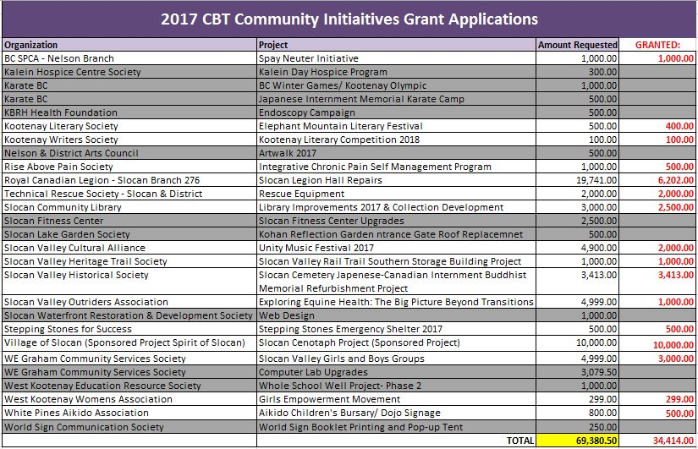  Moved by Councillor Perriere, seconded by Councillor Pelletier,  And Resolved:  That staff provide Council with a future report on alternative ways to undergo the funding selection process.
Adjournment  2017/81 | Moved by Councillor Van Bynen,  And Resolved:  That the meeting be adjourned at 9:30 p.m.

_____________________________
CERTIFIED CORRECT: Mayor

________________________
Chief Administrative Officer

